**TRACING THE GROWTH OF THE GLOBAL COMMUNITY:**

**A POPULATION FORECASTING ANALYSIS**

**INTRODUCTION**

**OVERVIEW:**

**The world’s population is more than three times larger than it was in the mid – twentieth century. The global human population reached 8.0 billion in mid – November 2022 from an estimated 2.5 billion people in 1950, adding 1 billion peoples since 2010 and 2 billion since 1998. The world’s population is expected to increase by peak at nearly 10.4 billion in the mid – 2080s.**

**This dramatic growth has been driven largely by increasing numbers of people surviving to reproductive age, the gradual increasing in human lifespan, increasing urbanization, and accelerating migration. Major changes in fertility rate have accompanied this growth. These trends will have far – reaching implications for generations to come.**

**PURPOSE:**

**A population projection gives a picture of what the future size and structure of the population by sex and age might look like. It is based on knowledge of the past trends, and, for the future. On assumptions made for three components: fertility, mortality and migration. Understanding population growth is important for predicting, managing, monitoring, and eradicating pest and disease outbreaks. Different evolution assumption are made for each component, constituting different scenarios. The projections serve as a basis for long-term thinking, particularly in terms of collective development. They make it possible to analyse population trends if the assumptions are true, but are not forecasts. Individual behaviour, certain public policy actions, scientific progress are unforeseen events ( weather events, epidemics) in the coming years may have lasting effect and significantly influence trends, which type projection do not take into account.**

**PROBLEM DEFINITION AND DESIGN THINKING**

**EMPATHY MAPPING**

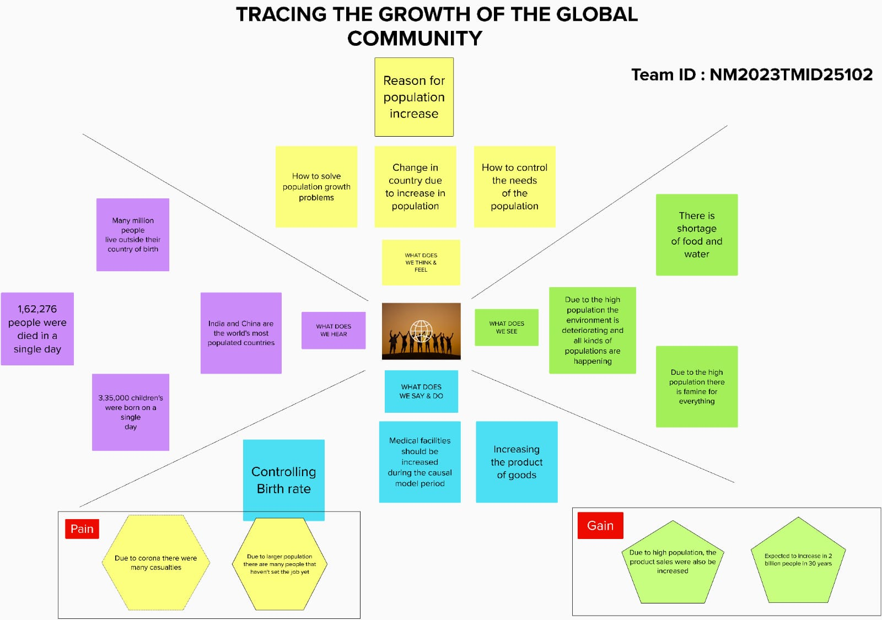

**BRAINSTORMING AND IDEATION**

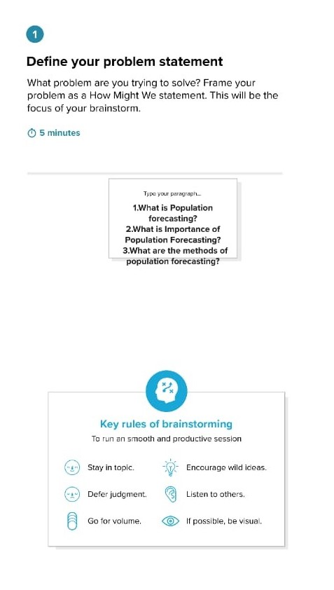 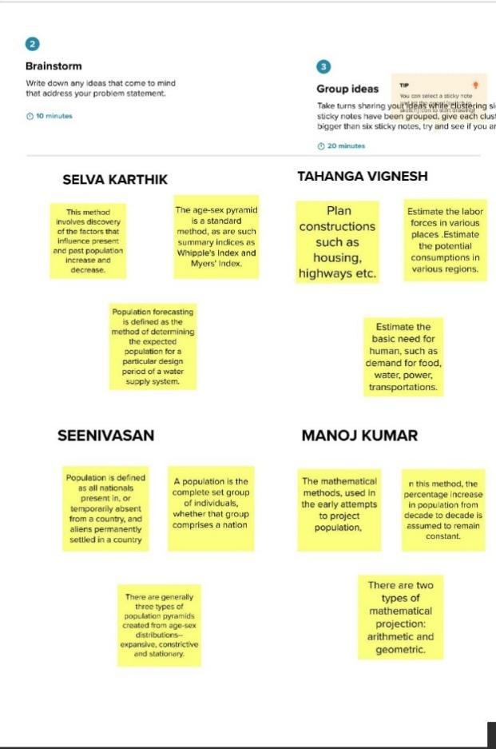

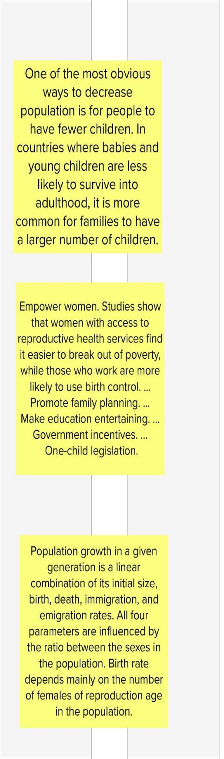 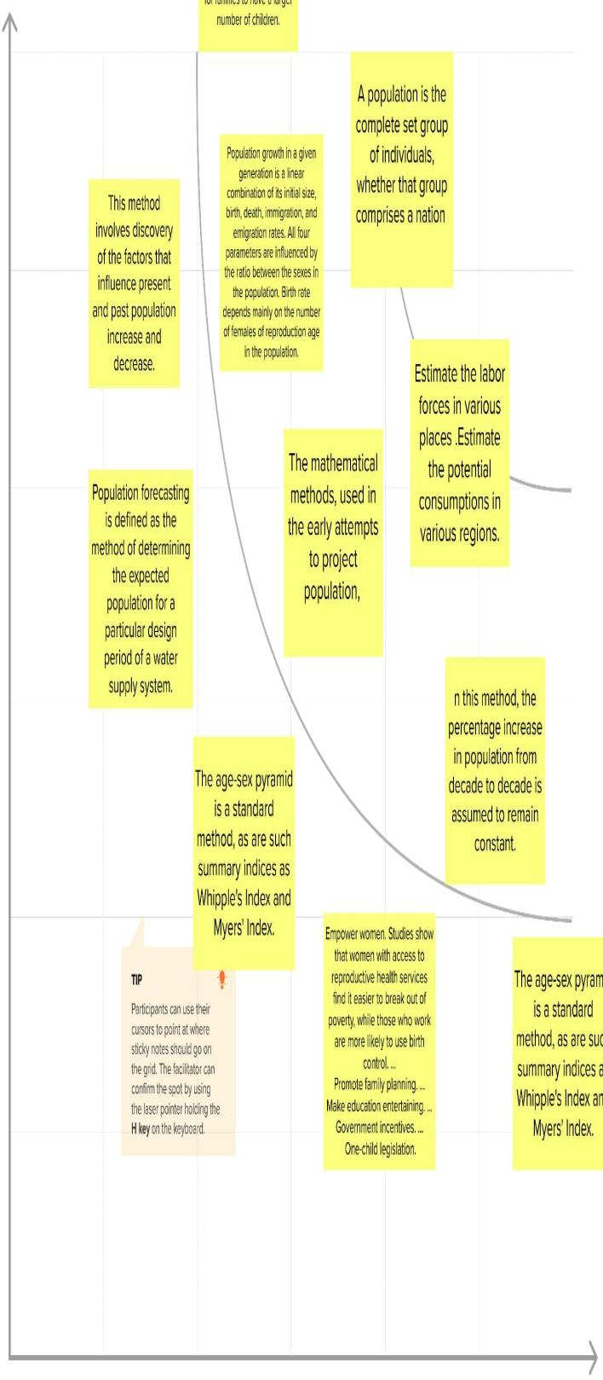

**ACTIVITY1.1**

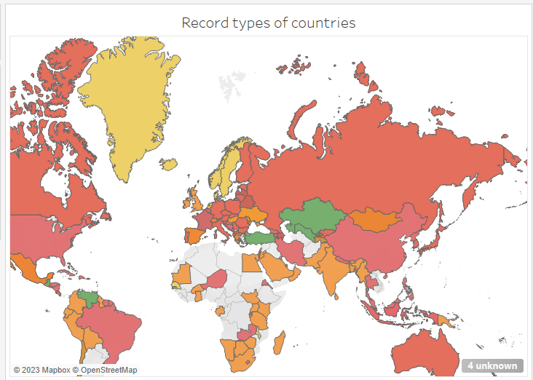

**ACTIVITY 1.2**

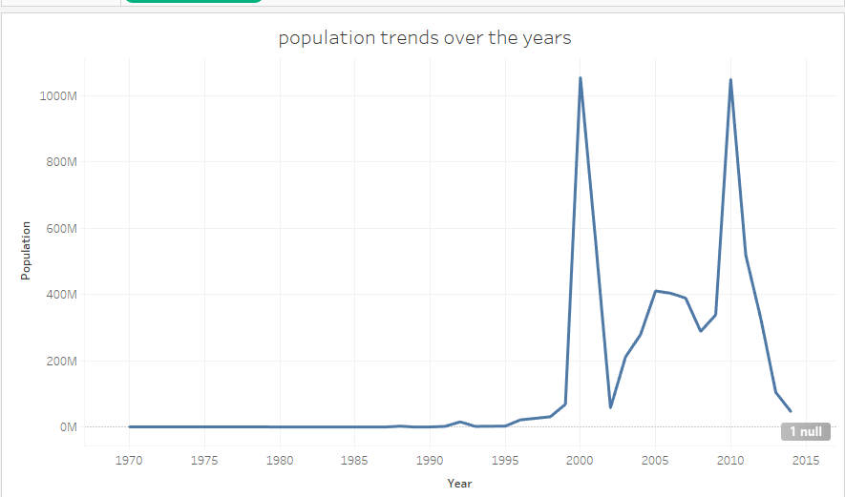

**ACTIVITY 1.3**

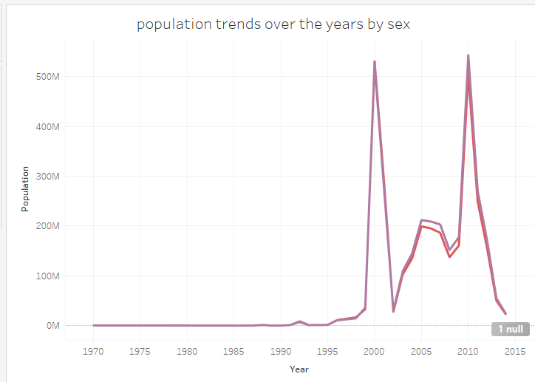

**ACTIVITY 1.4**

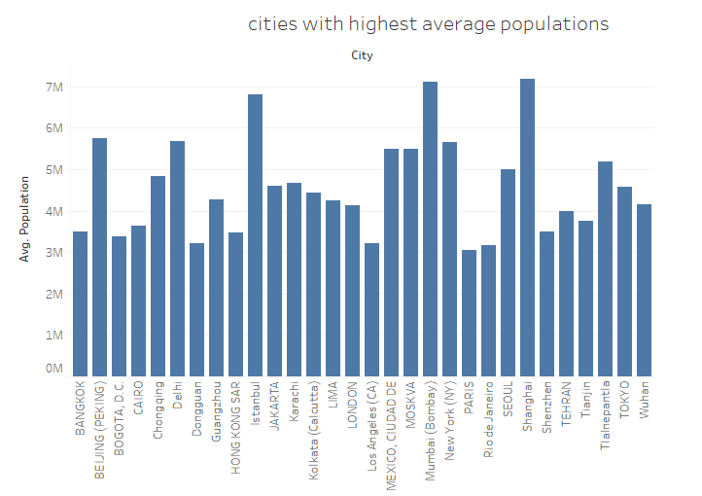

**ACTIVITY 1.5**

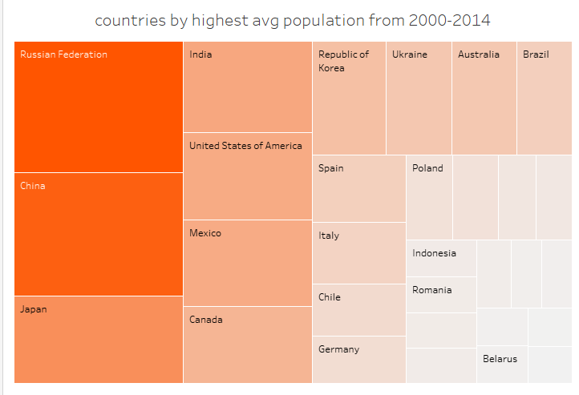

**ACTIVITY 1.6**

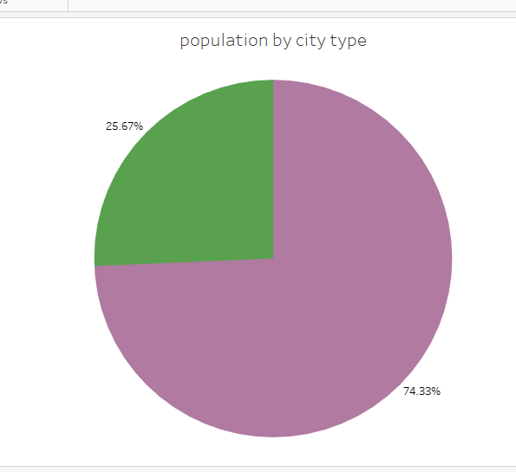

**ACTIVITY 1.7**

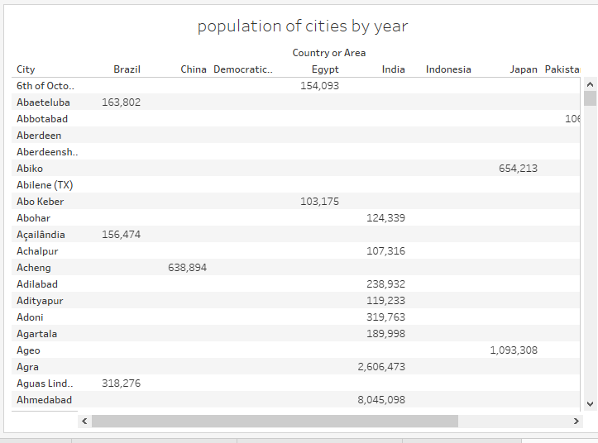

**ADVANTAGES:**

* **Estimate the basic need for human, such as demand for food, water, power, transportations.**
* **Benefit sociological research, such as providing about sex ratio or age ratio.**
* **The users of population projections that many people think of first are government departments responsible for policy and planning in different sectors.**
* **The population is one of the important factors which helps to balance the environment, the population should in a balance with the means and resources.**
* **Population growth will lead to economic growth with more people able to produce more goods.**
* **Population forecasting is an integral part of design. It is essential to take into account the population at the end of the design period.**

**DISADVANTAGES:**

* **The relationships between the various factors are complex and largely unknown.**
* **The reliability of projections decreases over time, and projections tend to be less reliable in periods of rapid change.**
* **Projections for areas with small populations tend to be less reliable than those for areas with large populations.**

**APPLICATION**

* **There are application associated with population growth, including, human evolution studies, the population growth is helped to study and observe the advancement in both anatomy and physiology.**
* **The growing population can be result of many advantages of beneficial trades or characteristics.**
* **The population growth of any kind of evaluation in a population can also provide information on how the species changed and evolved with time.**
* **Population growth also a play a vital role in the prediction of the endanger or threatened species or organisms.**

**CONCLUSION**

From this project we conclude that a population forecasting analysis, we conclude this using the following charts

* Population records by type of countries.
* P**opulation trends over the years**
* Population trends over the years by sex
* Cities with the highest average population
* Countries with highest average population from 2000-2014
* Population by city type
* Population of citied by year

FUTURE SCOPE

The world population is expected to increase by nearly 2 billion persons the next 30 years, from the current 8 billion to 9.7 billion in 2050 and could peak at nearly 10.4 billion in the mid 2080s. The current population of India is 2023 is 1,428,627,663 a 0.81% increased from 2022. The population of India in 2022 was 1,471,173,173 a 0.68% in 2021.

The UN population division report of 2022 project world population to continue growing after 2050, although at a steadily decreasing rate, to peak at 10.4 billion in 2086, and then to start a slow decline to about 10.3 billion in 2100 with a growth rate at the time of -0.1%.

APPENDIX

**SOURCE CODE**

For further information Click the link below

Dashboard:

<https://public.tableau.com/views/Dashboard1_16818011917570/Dashboard1?:language=en-GB&:display_count=n&:origin=viz_share_link>

Story:

<https://public.tableau.com/views/Story1_16818013605070/Story1?:language=en-GB&:display_count=n&:origin=viz_share_link>

Web application:

file:///D:/collage/Downloads/Day/index.html